**Task-2 : Cloud Monitoring and Alerts**

**SET UP MONITORING FOR A CLOUD BASED APPLICATION USING AWS CLOUDWATCH, GOOGLE CLOUD MONITORING, OR AZURE MONITOR**

**DELIVERABLE: CONFIGURED ALERTS AND A DASHBOARD SHOWCASING METRICS**

**Creating an alert using email notification**

Search cloudwatch → Go to alarm → create alarm

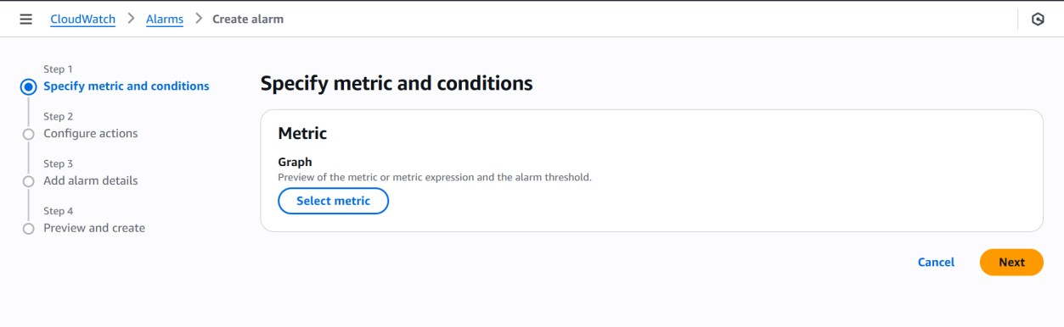

Here select metric → Go to browse →EC2 → Per-Instance Metrics → Select any instance with CPU Utilization → select metric

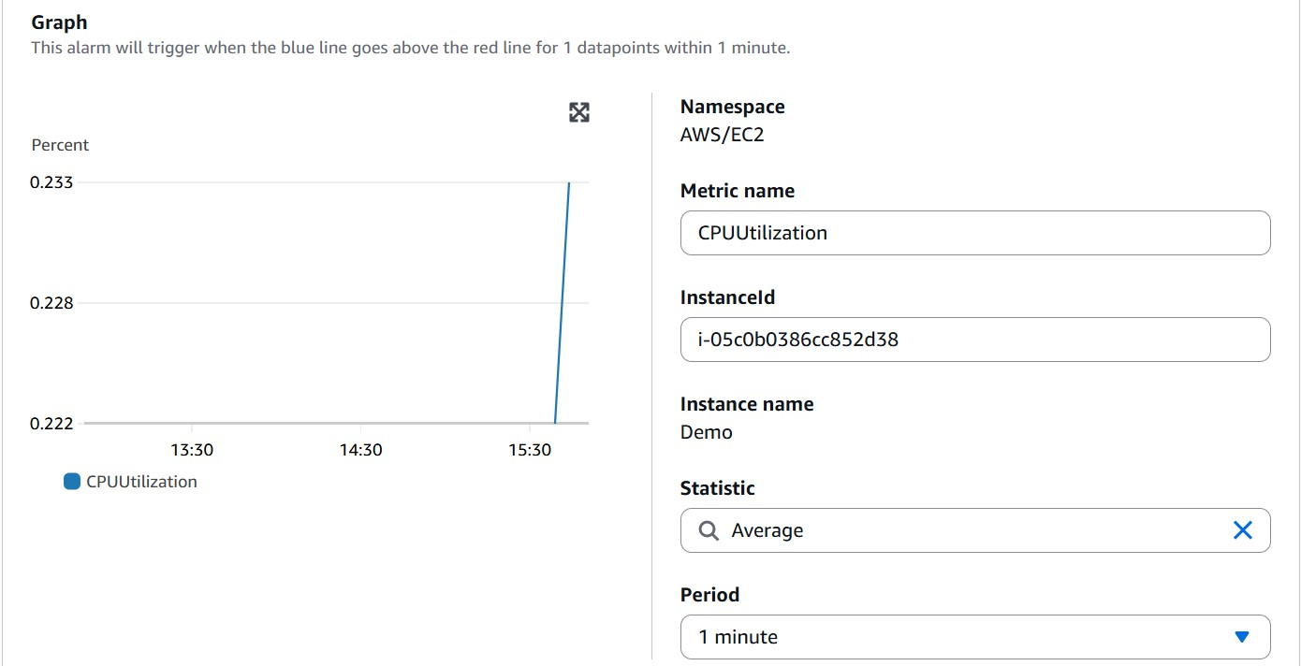

Do some change like

* Period → 1 min
* Statistic → average

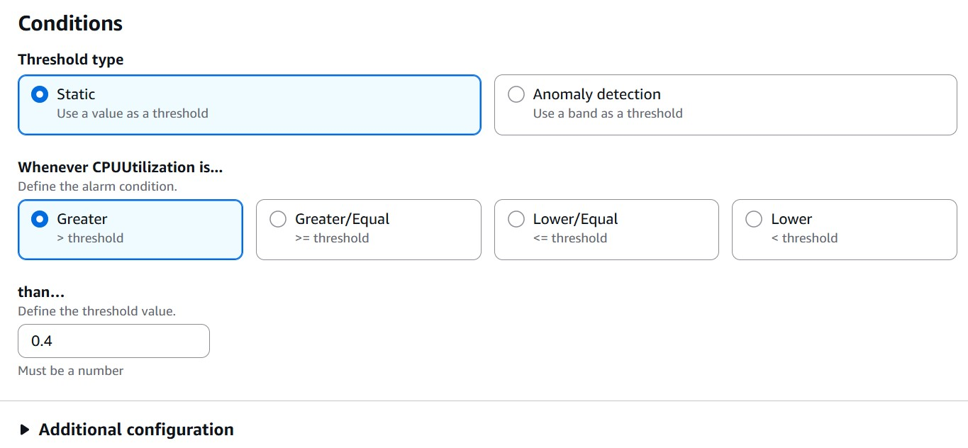

Do some change like

* alarm condition → Greater/Equal
* threshold value → 0.4 your chooses

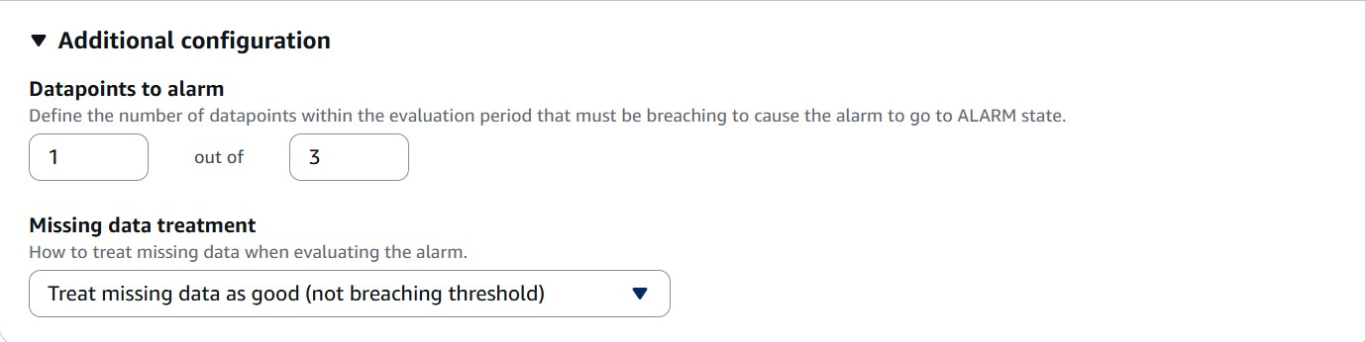

keep this as per the period for 1 min → 3 unit

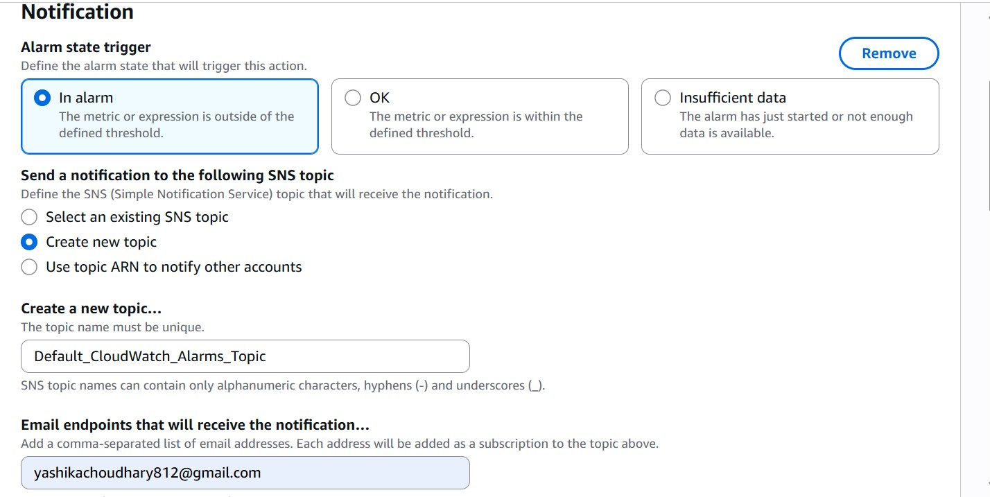

Set the notification setting

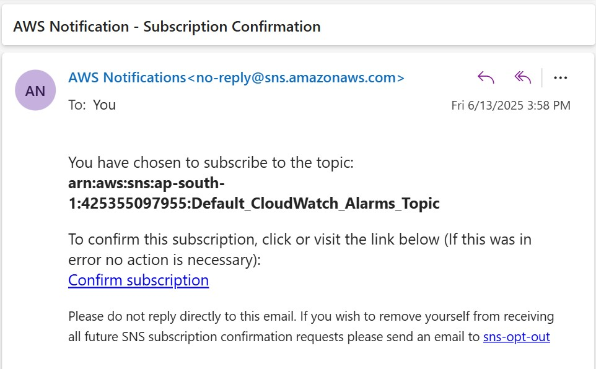

you will get an email to confirm the subscription

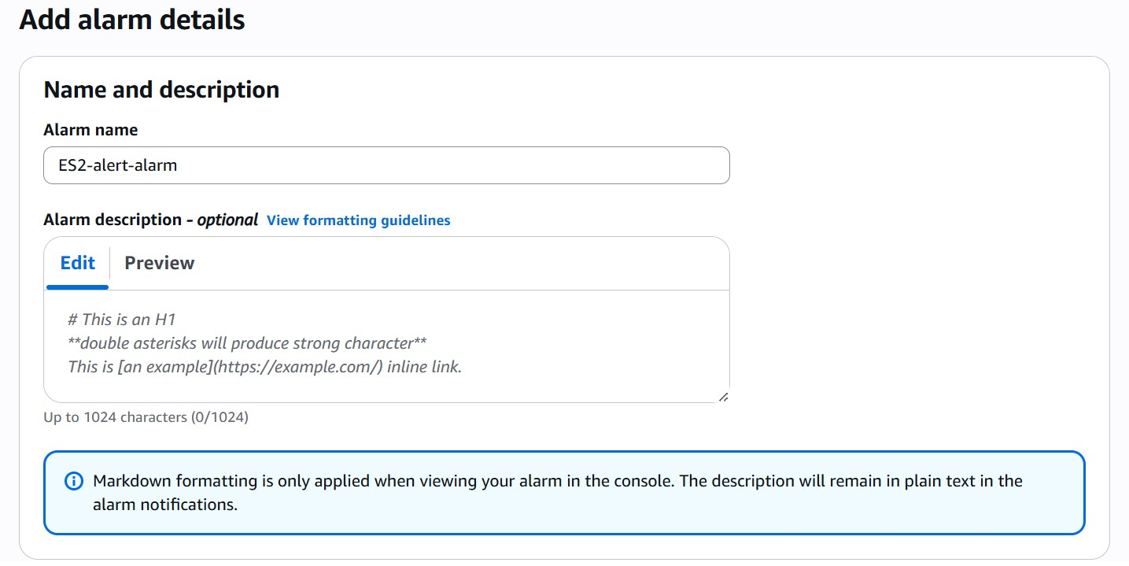

Give the name for the alarm

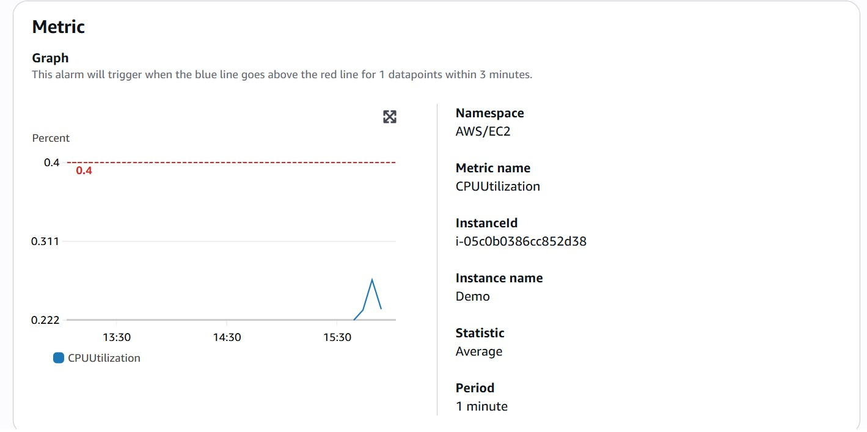

You will get a preview of all the details → click create alarm

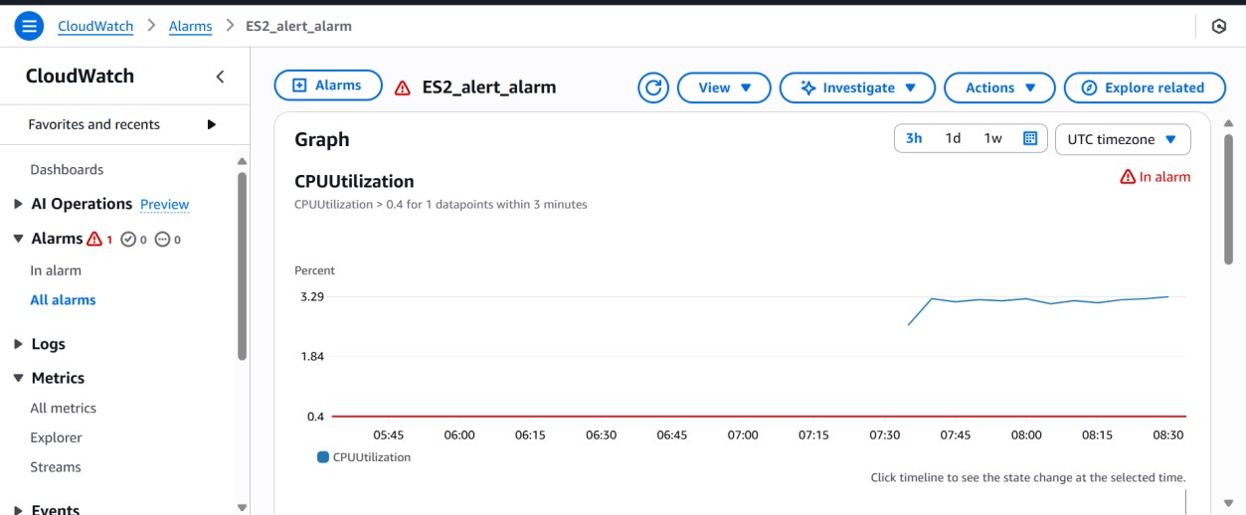

here i got an warring alarm (this will take same time)

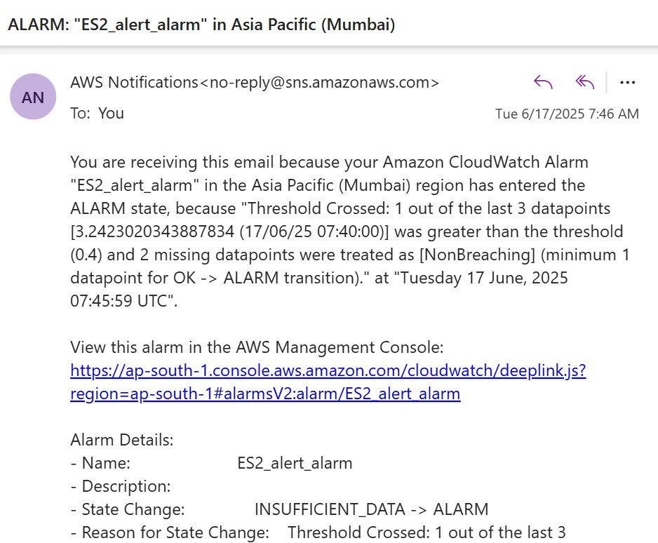

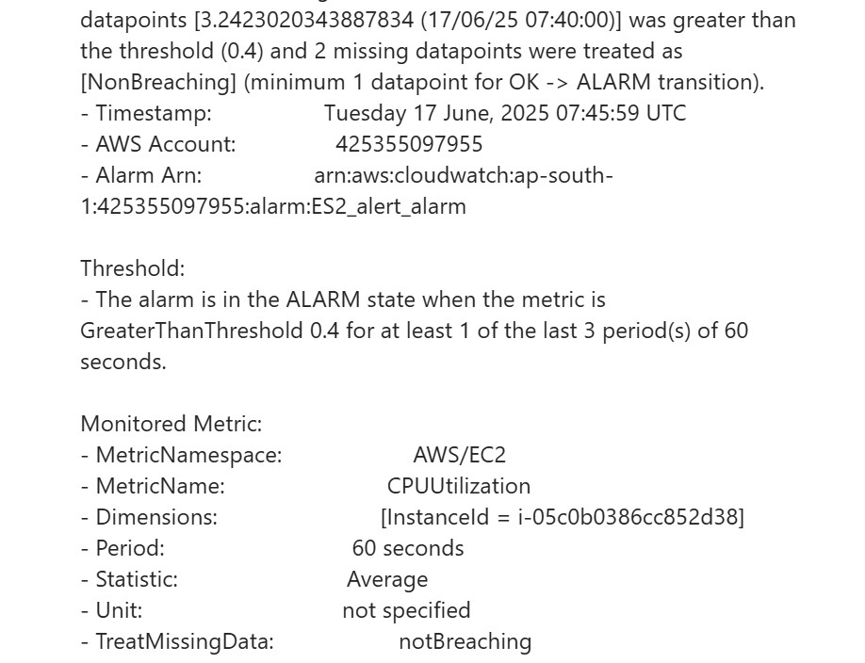

And you will also get an email for the warring as you had put notification for email

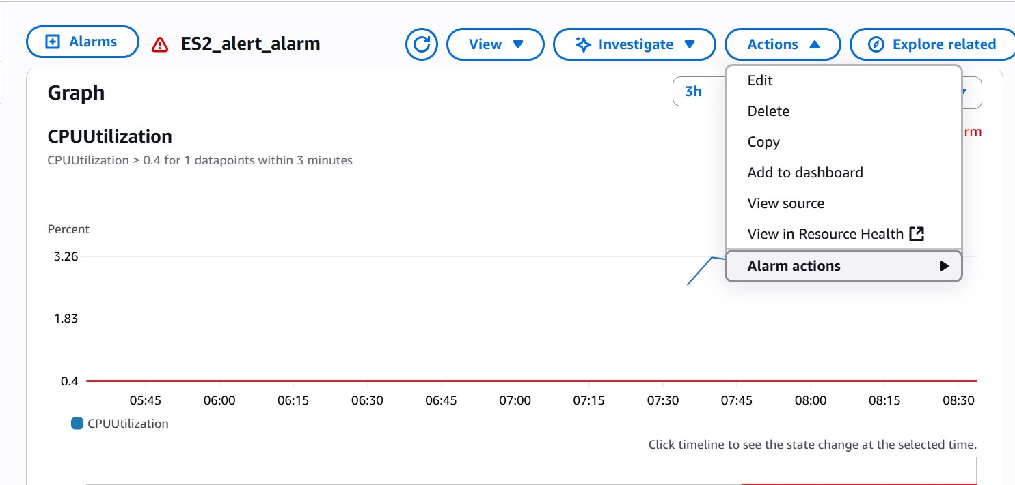

After using the Disable the alarm.

**Creating a Dashboard for an Instance that will showcase matrics**

First go and start your instance

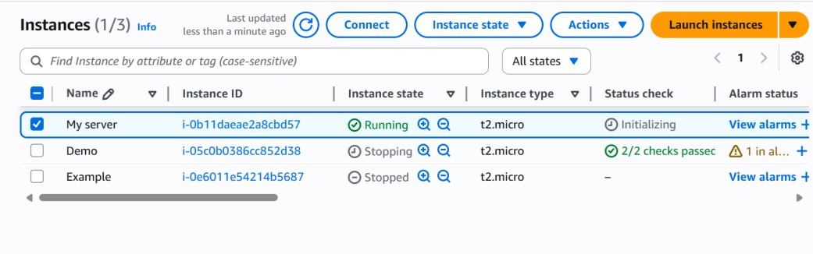

Go to connect

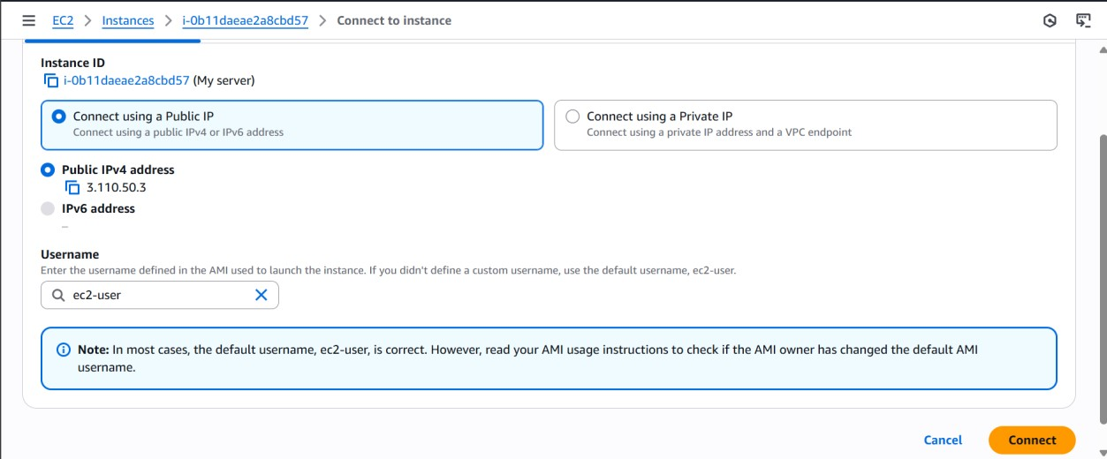

click connect

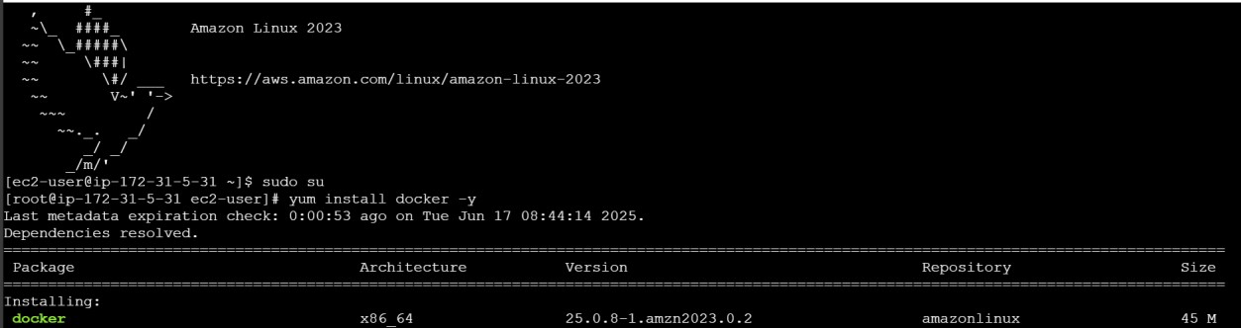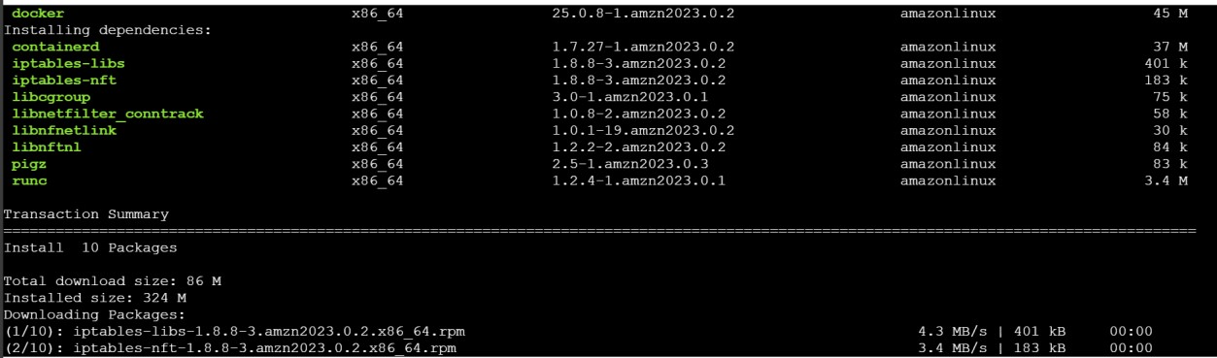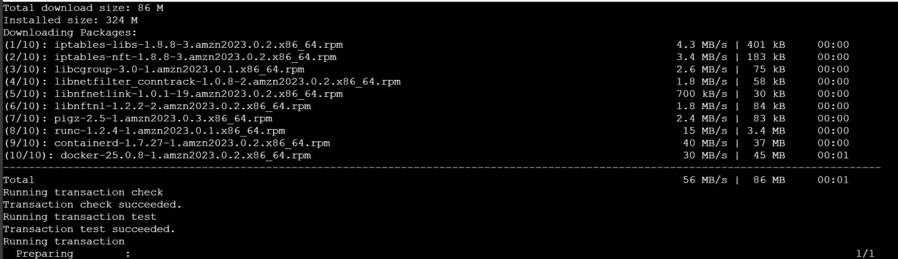

Type the following commands

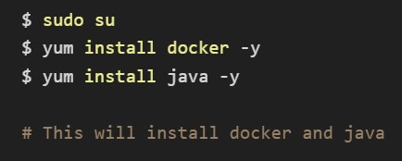

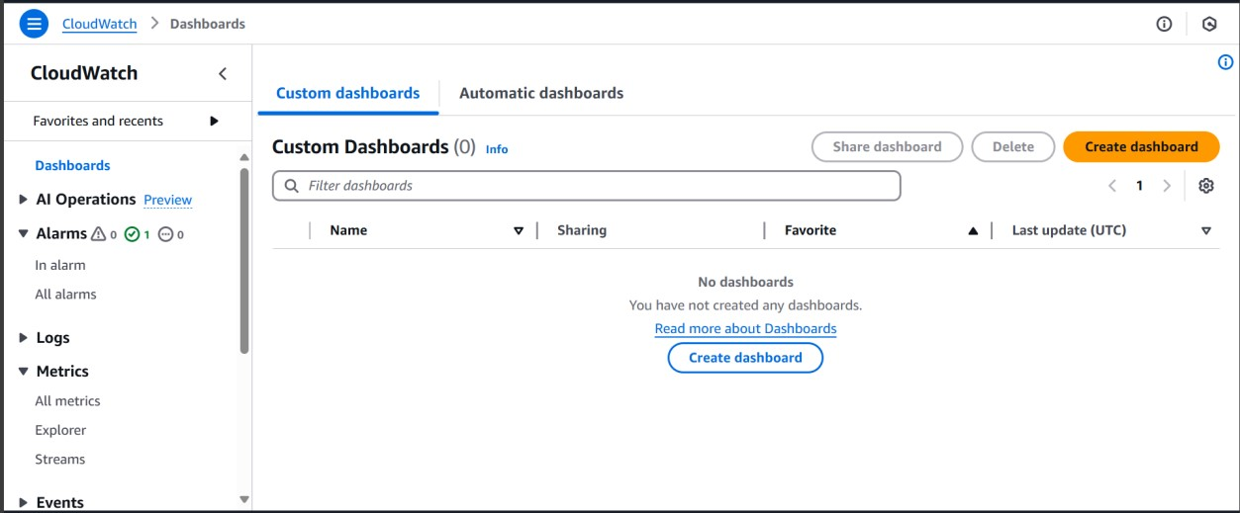

Now go to Dashboard Search Cloudwatch → right side click Dashboard. Click Create dashboard

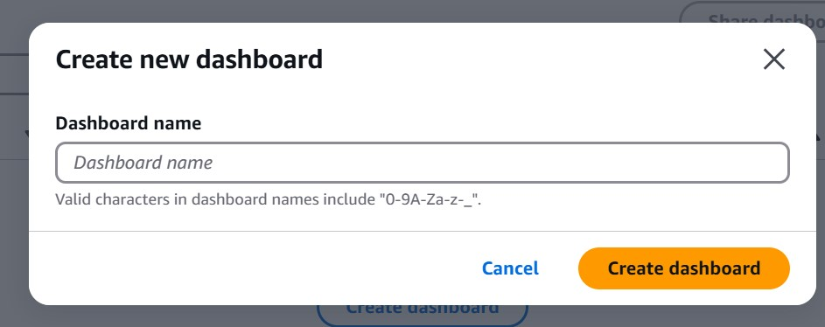

Give a name for your dashboard

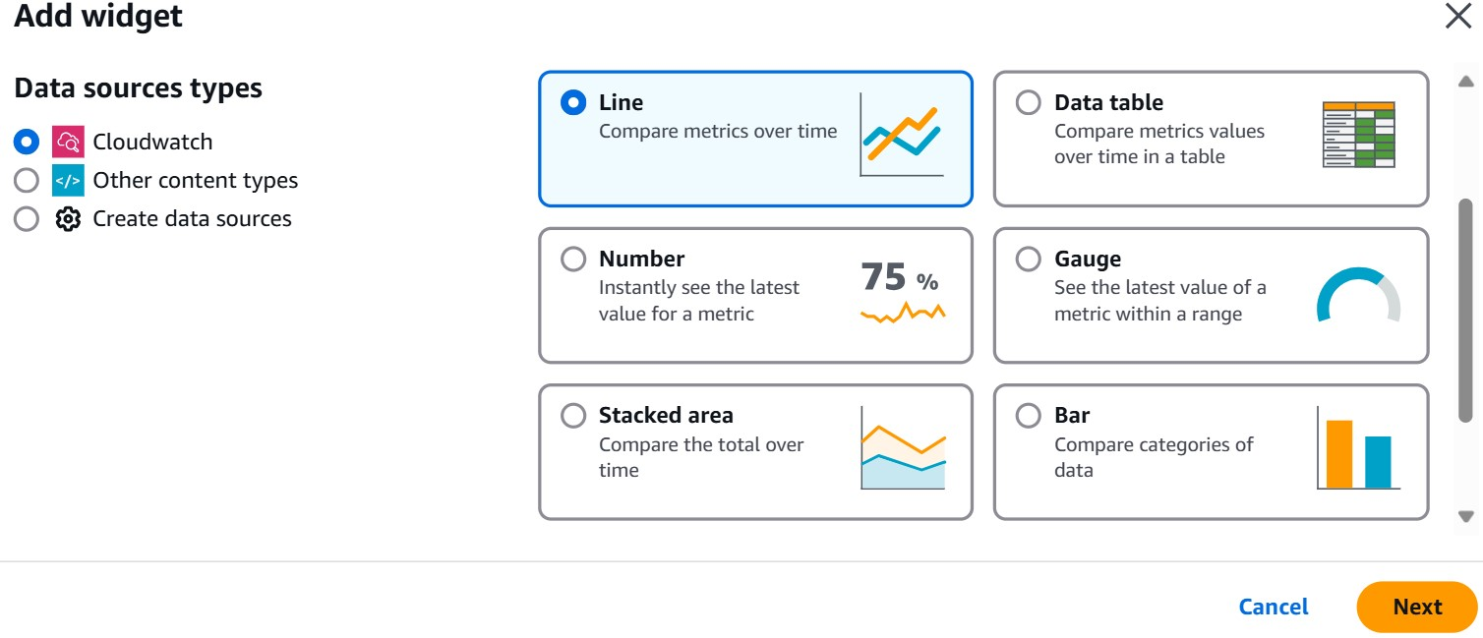

Add the type of Datatype and widget you wanted like

* Line Graph
* Number Graph
* Bar Graph

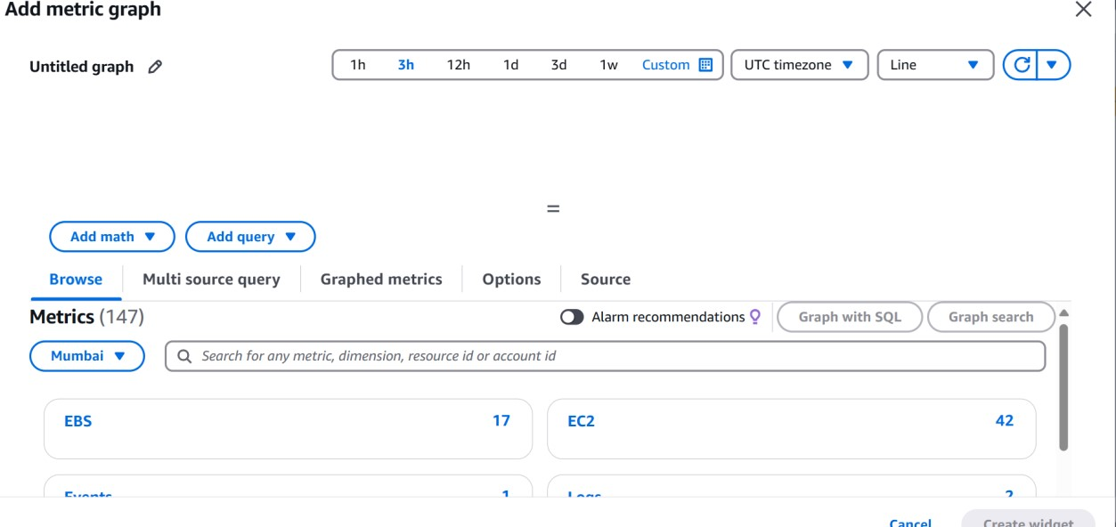

After selecting a graph then, Go to EC2 → Per-Instance Metrics

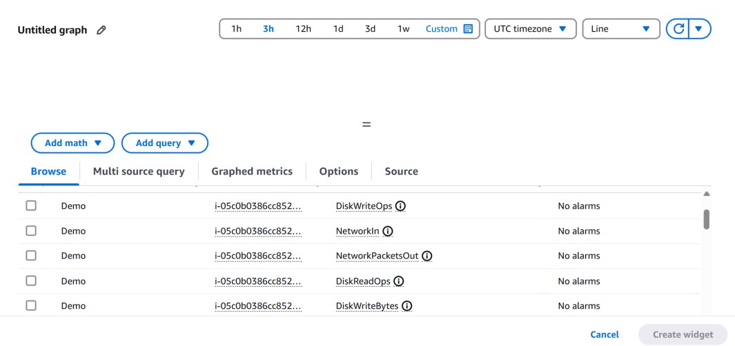

Select the type of resources you want the statistics for

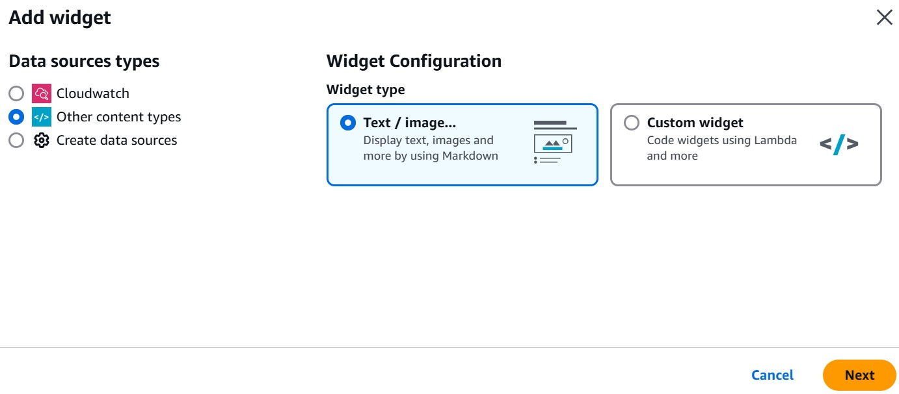

You can also give a description for your Dashboard click next

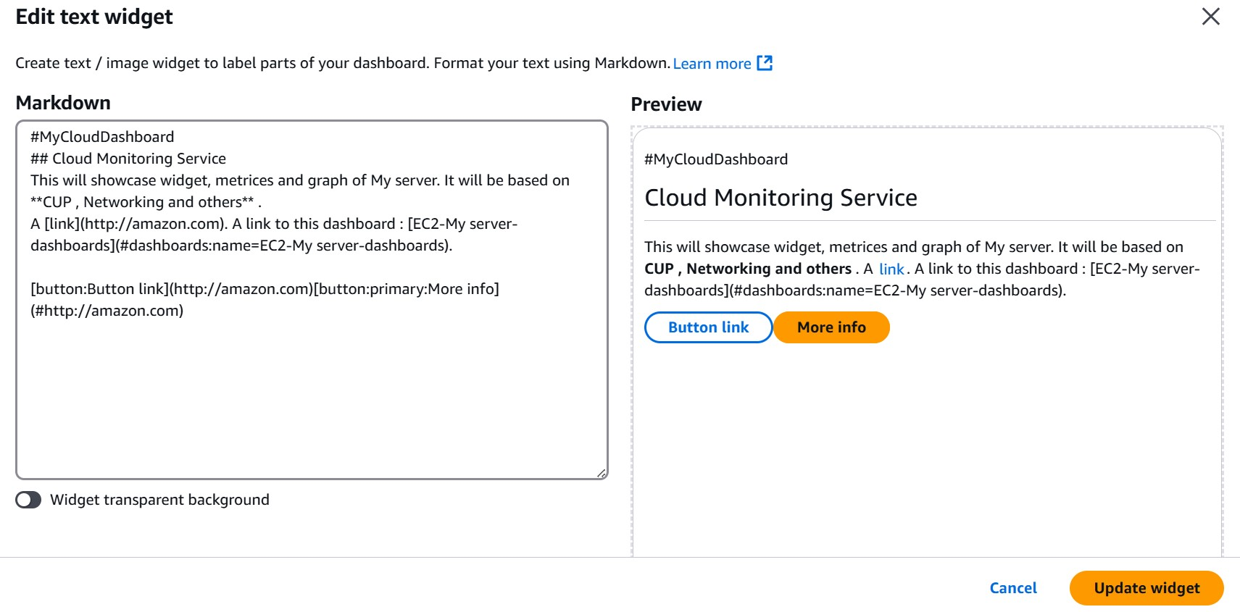

Here you can edit your description what you want

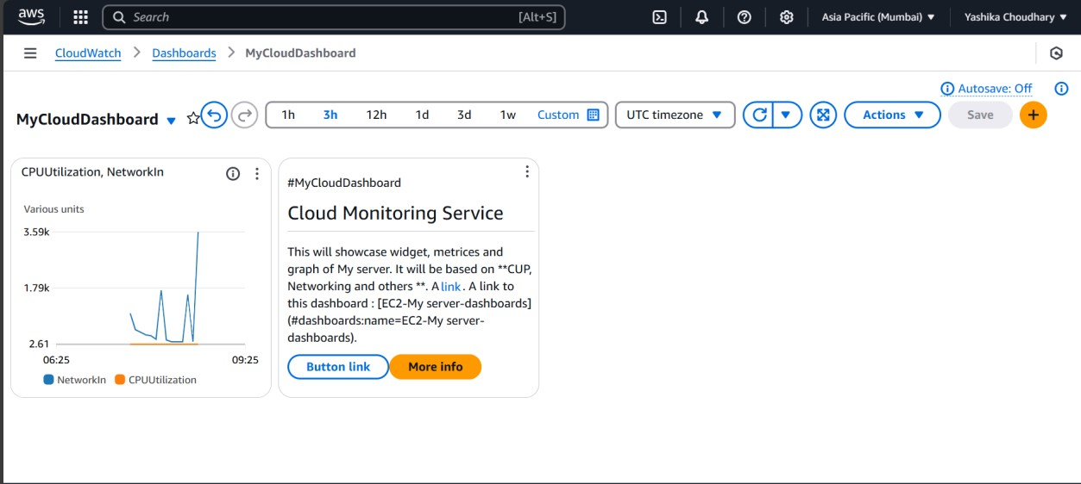

This is how the Dashboard will look try doing some more computation usage to get more statistics.